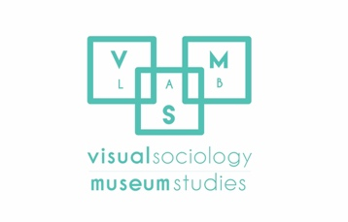

Application Form for Art & Research Residency
Visual Sociology and Museum Studies Lab

Please fill in the application accordingly and e-mail it to theopisti.stylianou@cut.ac.cy

- Personal/ Contact details

Title (Mr, Ms, Dr)
Name/Surname

Gender | Date of birth
Nationality
Permanent address

City | Post code
Telephone | Fax
Email address
Dates available for residency program (please specify exact dates)

- B. Education

Higher education (University/ College, Course title/ subject, from dd/mm/yy to dd/mm/yy)

Other educational achievements (prizes or awards)

- Write a short proposal about your project and how the VSMS Lab can be of help. Briefly discuss the research or rationale behind your project. We recommend that you describe the specific equipment you might need to use. Please also include a detailed timetable of your project and whether or not you expect to complete it during your residency
(400-500 words long).
- References (Please supply the names and contact details of two referees - we will only contact the referees if needed)

Name/Surname
Job position
Email address
Telephone
Name/Surname
Job position
Email address
Telephone

ADDITIONAL MATERIAL:
- Along with this application please send a detailed CV.
- (OPTIONAL) If you are a visual artist we encourage you to send a small sample of your work (PDF file under 4MB or link to your website)

